Alec Baird

Software Engineering

Microsoft : Software Engineer II

Interests : Walt Disney – US Defense – Microsoft – Silicone Valley

Your LinkedIn states that it helped you to get a job. Can you share what I can do with my LinkedIn account to better my odds at finding a job?

I’m really interested in Microsoft. What are some of the daily projects that you work on?

What kind of projects could I do now to prepare myself for working at Microsoft?

What are some of the best resources for learning Microsoft Azure?

What are some of the ways the growth of AI has affected work at Microsoft?

Thomas Wood

Software Engineering

TWI – Cloud solutions/3D rendering Data Analyst / Additive Manufacturer Administrator

Interests : Aerospace – Programming – Operating Systems

Your LinkedIn shows that you have a lot of knowledge with operating systems. How has that helped you in your career?

Can you tell me how I can learn about the Microsoft Power Platform?

How would you recommend I come up with project ideas while I’m in school?

Should I learn Linux?

What are some of the ways the growth of AI has affected work at Microsoft?

I couldn’t get a message sent:

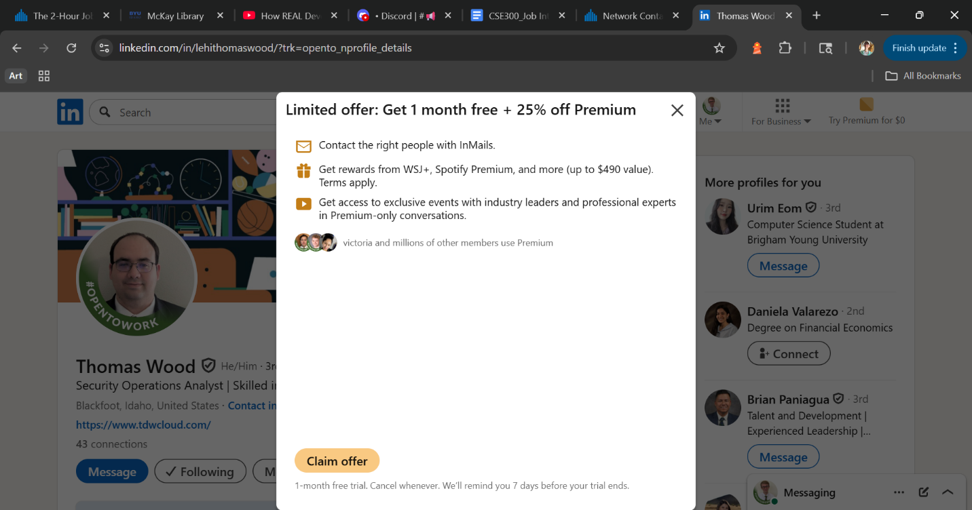

Sheldon Jensen

Software Engineering

Hill Airforce Base Software Engineer

Interests : React – Front end development

What kind of projects do you work on in front end development?

What do you like about working at the Hill Airforce Base?

What kind of projects would help me to learn front-end and backend development?

How has AI changed the way that you work?

How do you find good events to attend to learn more about programming?

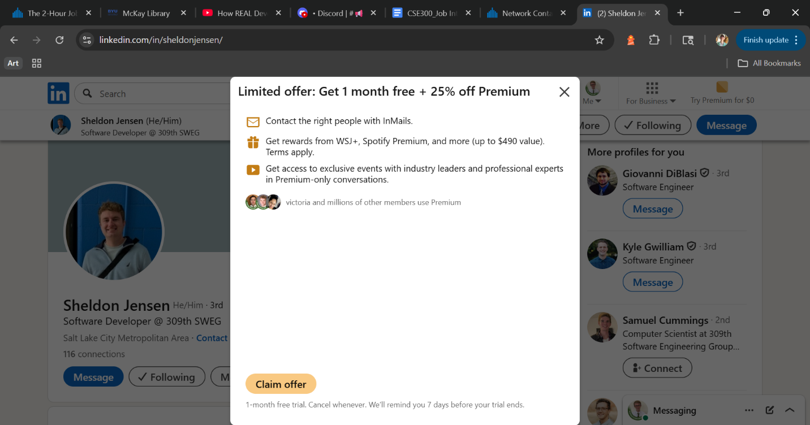

Conrad Rife

Software Engineering

Microsoft Software Engineer II

Interests : Aerospace – Comics – C#

What do you like about working at Microsoft?

I’m really interested in Microsoft. What are some of the daily projects that you work on?

What kind of projects could I do now to prepare myself for working at Microsoft?

What are some of the best resources for learning Microsoft Azure?

What are some of the ways the growth of AI has affected work at Microsoft?

